**Accounting Principles Assignment**

21102052 Lee Jeong-Yun

1. Assignment #3 – due to May 30, 2022
2. Please find the news article, describing a UK or US company’s financial situation or recent financial performance. Please summarize the main content of the new article by more than five sentences.

You may visit Financial Times ( <https://www.ft.com/> ) or The Wall Street Journal ( <https://www.wsj.com/> ).

1. Please find the company’s financial statements on the Internet. You can visit the website for the US company’s financial statements:

<https://www.sec.gov/edgar/searchedgar/companysearch.html>

1. Please find the original numbers to which the news article refers. Please include the company’s financial statements in your report.

**Abstract of New Article**

Apple announced that it could suffer losses of up to $8 billion due to a lack of supply chain by pandemics and other factors.

Apple's March quarter earnings rose 6% to $25 billion.

Revenue was partly improved by record earnings from the group's services sector, which rose 17% to $19.8 billion.

iPhone sales rose 5.5 percent, accounting for $50.6 billion, or 52 percent of total sales.

Mac-related sales rose 15% to $10.4 billion.

The wearable device-related sector achieved $8.8 billion in sales.

In the case of iPad sales, it was reported as $7.7 billion, down 2%.

* Product Sales = 50.6B+10.4B+8.8B+7.7B = 77.5B
* Service Sales = 19.8B

Source:

Patrick McGee. (2022, April 29). *Apple forecasts up to $8bn hit from supply chain problems.* Financial Times

Product Sales: 77.5B

Service Sales = 19.8B

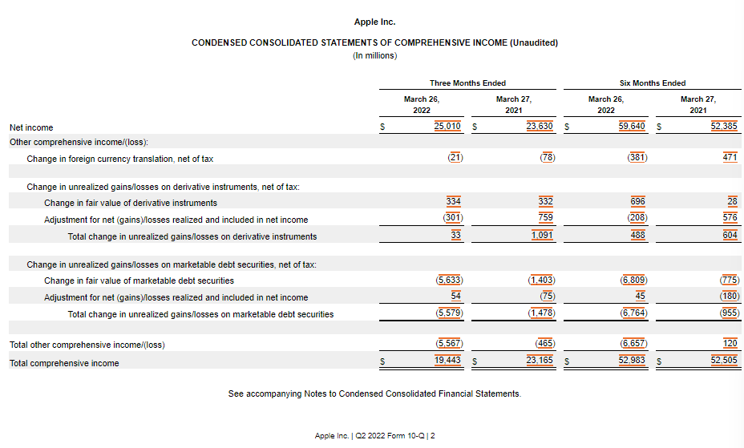

Earning = $25,010M = $25B

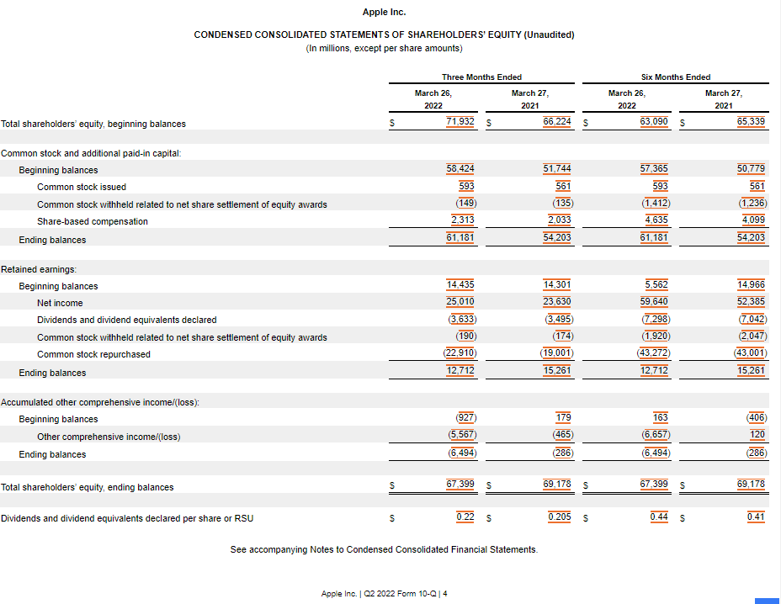

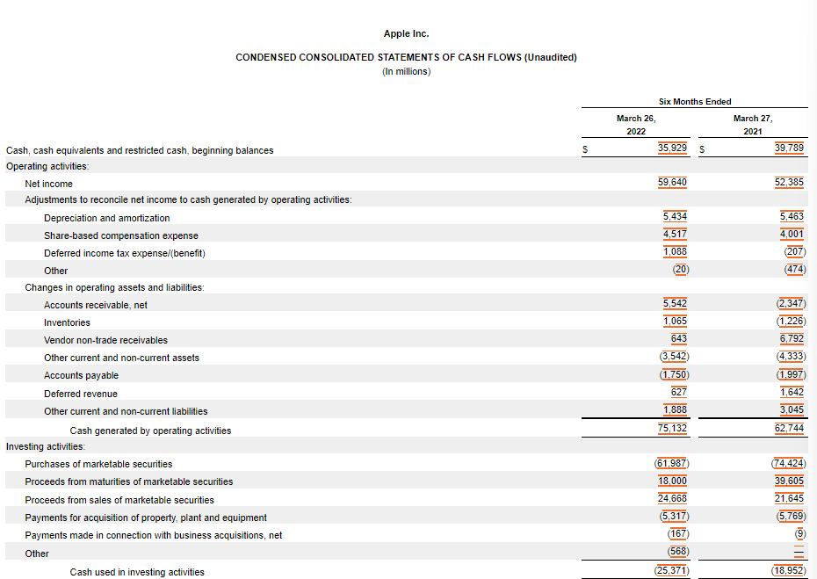

<https://www.sec.gov/ix?doc=/Archives/edgar/data/320193/000032019322000059/aapl-20220326.htm#if7fa3f006dec4814b60d40d3f7dd9e6c_13>